`
Alaska Transition: Pathway to Adulthood & Employment

Your Blueprint for Transition

Part 1: Defining “Employment” and “Transition” in Alaska

Parents and teachers have already realized that their children’s “transition” begins much earlier than the final year of school. There are many opinions on how old a child has to be to begin to learn about exploring work and the options that exist.

The Table in the appendix 1 illustrates a possible set of steps that might be taken by children, parents and teachers. This table begins at age 12 and continues to age 24, and is broken into 4 age groups. These age groups are not necessarily arbitrary, and have been published to enable serious conversations between students, parents, and school personnel. Currently, at age 16, the Division of Vocational Rehabilitation representatives are to attend IEP’s. This happens in many cases, and is a very good way of introducing real employment information into the meetings. As of this writing, the Workforce Investment and Opportunity Act (WIOA) has directed all state vocational rehabilitation agencies to earmark 15% of their yearly budget for the PETS program (Pre-employment Transition Services) In most cases, this program will begin at age 14 – age 21 for people who have IEP’s in the schools.

Required services of PETS with include:
- Job exploration counseling
- Work based learning experiences
- Counseling on post-secondary opportunities
- Workplace readiness training
- Training on self-advocacy
- Additional specified activities if funding is available

“ Pre-Employment services (PETS) are for all students with disabilities in need of such services, without regard to the type of disability.” *

* From the Direct Course Webinair, Presented by: Elsevier, the University of Minnesota, and the Institute for Community Inclusion, UMass, Boston
Alaska is an Employment First State.
Thursday, May 29, 2014, Anchorage, Alaska – Representative Charisse Millett’s bill that makes Alaska an Employment First State was signed into law by the Governor today.

- Governor Parnell signs House Bill 211, which directs state services for individuals with disabilities to be focused on the primary objective of finding gainful employment for those individuals.
- “ You have a state delivering more efficient services at less cost, and people who need theses services having better outcomes as a consequence. What’s more, employers are enthusiastic, reporting about the positive experience having a worker with a disability has been for their organizations.” Millet said.

This does not mean that integrated employment is the only vocational outcome for people graduating from school, but it is the first choice.

And this from Alaska Senior and Disability Services (SDS) regarding waiver services for supported employment activities:

- Between April 1, 2015 and September 30, 2015, there were 101 unique IDD recipients between the ages of 16 and 26 receiving supported employment services.
- The total cost for supported employment services for the group during this time was $683,104.

And from Alaska Division of Vocational Rehabilitation:

Federal Fiscal Year 10/1/2014 – 9/30/2015

Total Number of Youth with Disabilities Employed: 104 13% of all workers
All Youth Average Wages: $11.63 27 hrs. /wk.
Total of Youth/IDD Employed 75 72% of All Youth
Youth/IDD Avg. Wages $11.69 27 hrs./wk.

** For the purposes of this document, employment is defined as: employment paid at the rate of minimum wage or above, and over 20 hours per week.

** Alaska DVR has not included the results of any self-employment ventures undertaken by its customers.

Part 2: Transition & Transition Services Best Practices

Transition planning is more than a name for the age-old challenge of helping special education students plan for life after K-12. Today, it is a federal requirement with performance metrics that elevate the issue from a special education challenge to one that schools, districts and states are now evaluated on and accountable for.

The five best practices for successful transition planning are:
- Student First Involvement
- Self-advocacy
- Goal Setting Using the person’s Strengths
- Self-monitoring
- Self-determination

From SEEN Magazine Fall 2015, Author: Carmen Cavolo

- Successful transition plans include a student’s preferences, interests, and personal needs. Research shows that when students are involved in their own transition planning process, they develop a critical sense of self-awareness that helps them understand their individual needs.
- Students who can successfully self-advocate can more effectively participate in their planning meetings, ultimately adding value to the plan itself.
- Goal setting is what a student lends to the process for educational and employment goals and is critical to his overall success.
- When students set their own goals and are in charge of monitoring their progress, they become accountable.
- All of these best practices ultimately lead to the concept of self-determination, the idea of determining what you will be, where you will go and why. The academic world has adopted the word “self-determination” to refer to students becoming involved in their own post-secondary education and employment plans and ultimately, determining their own futures.
In the IEP Meeting (Best Practices)
- Start on Time
- The student, parent, or the administrator initiates team member introductions
- Make sure that there is a note taker who records both the family’s and the site level personnel's comments
- Review the ground rules for the meeting. Basic rules:
- No interruptions
- Respect and dignity
- Summarizing (not reading) reports in 10 minutes or less
- Decide how to handle electronic/other interruptions. It is suggested that pagers and phones be turned of to give the meeting its due importance.
- Confidentiality
- Caucus (private meeting)
- Consensus (decision making process, not a “majority vote”)
- Establish time parameters or constraints; agreement that all participants remain during the whole meeting if at all possible; appoint a timekeeper
- Breaks
- Review agenda
- Determine desired outcomes
- Encourage participation from all team members
- Ask open-ended questions
- Be non-judgmental
- Check for understanding and clarity; ask for specifics
- Keep the group focused on the task at hand
- Build on small content agreements
- Reframe emotionally charged statements
- Summarize periodically
- Acknowledge accomplishments
- Confirm agreements
- Determine action plan and schedule follow-up activities

(from: www.pent.ca.gov/cns/best practices_as.pdf)

Part 3: Who are the Parents and What is Their Role in Transition?

What has traditionally been viewed as a parent(s) devalues/excludes youth who do not have this traditional model as a part of their lives.
How can we move beyond this definition of “parent” into an understanding of a support systems?
Such as:
    - Biological or Adoptive
    - Foster
    - Grandparents
    - Older Sibling
    - Adult Ally

The Role of Parents/Support System
- Parents are sometimes the one consistent relationship in a young person’s life.
- Parents often provide, among other things:
  - Food
  - Shelter
  - Transportation
  - Medical Care / Disability-related Access Support
  - Learning Educational Laws (www.wrightslaw.com)
  - Keeping track of appointments
  - Support for young person’s dreams

What Parents Wish You Knew

- Parents often feel, due to prior experiences, they are asked to participate in meetings simply because it is required and do not feel their contribution is valued nor listened to.
- “ Listen to me. This person is my son/daughter and I know them for a lot longer and much better than you.”
- “I can go to school to learn what you know, there is nowhere for you to go to learn what I know.”
- “I know you do this every day but these concepts are sometimes frightening, please respect and recognize my feelings.”

Outreach to Parents

- Make sure that you always involve them, and keep them informed, from the beginning!
- Maintain Confidentiality
- Encourage parents through outreach to be as involved as possible. That is critical!
- Keep parent apprised of drastic changes in the young person’s life
- Send home information and updates to help parents know where they can provide support
- Facilitate a Parent Mentorship Group
- Create an open forum for parents to discuss positive outcomes and air their concerns
- Moderate to ensure the group keeps their young people in the “driver’s seat”
- Teach strategies for helping young people to become more independent
- Possible Hurdles:
- Parent’s Work Schedules/Activities
- Past Experience/Lack of Trust/Disconnection
- Prior Harmful Behavior on “Experts” Part
- Dependence on Social Security Benefits/ No Knowledge of Work Incentives

From ILRU Powerpoint: “New Community Opportunities Center at ILRU Presents…
“CIL Strategies for Involving Parents in the Transition Process” (2011)
Presented by: Aaron Baier, Jayne Chase, & Steve Milbern

DVR eligibility, basic link
Traditional Role of the Division of Vocational Rehabilitation (DVR) in School to Work (STW) Transition Services (Age 16)
PERIOD I (2 to 3 Years Prior to Graduation):
  - Consult with and educate schools, parents, students, and other agencies about VR services
  - Conduct outreach to include VR orientation presentations, dissemination of VR brochures, and technical assistance with transition IEP planning
  - Participate in transition fairs, job fairs, and other activities targeting parents and students to increase appropriate referrals
- Conduct early identification and assessment of student needs for transition services
- Communicate relevant VR policy which may impact a student’s application or eligibility for VR services
  - Participate in transition fairs, job fairs, and other activities targeting parents and students to increase appropriate referrals
- Conduct early identification and assessment of student needs for transition services
- Communicate relevant VR policy which may impact a student’s application or eligibility for VR services

PERIOD II (2 to 3 Years Prior to Graduation): Typically, a student is 16 years old before the DVR representative participates in a Transition IEP meeting unless the student is at risk of dropping out of school.
  - Participate in IEP meetings at the invitation of the school
Participate in other ways to assist the IEP team in planning transition services if unable to attend the IEP meeting
Link the student with other appropriate adult agencies that may provide services during the transition process and/or after the student exits school during the transition process and/or after the student exits school
Encourage student application for VR transition services
- Communicate relevant VR policy which may impact a student’s application or eligibility for VR services during the IEP

- Communicate relevant VR policy which may impact a student’s application or eligibility for VR services during the IEP
  - Determine eligibility (STW Counselor only)
Coordinate and provide payment for any assessment necessary for VR services (STW Counselor only)
- Counsel the student, parent and/or guardian on vocational goals, evaluations, recommendations, and discuss options for VR services so that they can make an informed choice
- Encourage career exploration, CBWE, mentoring, job shadowing, and volunteerism Provide guidance and counseling about work attitudes, habits, and behaviors Provide guidance and counseling about work attitudes, habits, and behaviors generally required by employers

Part 4: Post Secondary Transitional Employment Training Resources:

Transition services in the schools may also lead to post-secondary educational and employment opportunities. In Alaska, two facility-based services exist: Project SEARCH and the Tapestry Program at the University of Alaska/ Anchorage.

Alaska Project SEARCH

Modeled after a program that started at Cincinnati Children’s Hospital, Alaska’s Project SEARCH pairs students who have significant disabilities – including hearing or vision loss, autism, developmental delays, traumatic brain injuries or physical impairments, among others – with job rotations that allow them to pursue their interests as they work toward becoming independent adults.

Project SEARCH, depends on collaboration among education, business and vocational rehabilitation organizations for its success. Each year, students are selected from the Anchorage School District’s Alternative Career Education, Fairbanks School System, Kenai Schools, and Mat-Su Schools to take part in the Project SEARCH program in their communities.. They choose three different job rotations during their academic year. Like other high-schoolers, they attend class in the morning to receive instruction. From there, though, their classroom becomes the workplace. From 9 a.m. until 2 p.m., the students report to their jobs across the hospital – in Medical Records, Cardiopulmonary, HR, Imaging, Day Surgery, Sleep Center, Radiology, General Stores and more. There they perform a variety of duties, from delivering mail to preparing food to inventory control and filing.

Following their internships and education, the students are assisted to find jobs that correspond to their interests, strengths, experience and abilities in businesses in the community. They are contributing members of the community and nation.

Tapestry: The Alaska Transition Program for Students with Intellectual Disabilities at the University of Alaska Anchorage

The TAPESTRY project has developed a Comprehensive Transition and Postsecondary program at the University of Alaska Anchorage for 18-21 year olds with intellectual disabilities.

The program uses the resources of UAA’s Center for Human Development (UCEDD), the Disability Support Services, and the Community and Technical College, in partnership with the Anchorage School District and the Division of Vocational Rehabilitation. A Planning and Advisory Board—including parents, university students with disabilities, adult service providers, school district personnel, DVR staff, staff from the Alaska Senior and Disability Services Division, Alaska Developmental Disability Council members, Department of Labor and Workforce Development staff, and UAA faculty and staff—developed a workforce credential that provides a college-based education. TAPESTRY’s approach is based on Hart et al.’s (2006) Inclusive Individualized Support Model. Thirty-five youth with ID will earn a workforce certificate during the 5-year project.

Project goals include:
- Establish a CTP program resulting in a workforce credential that blends together experientially-based contact hours, audited and non-credit courses in work experience, academic enrichment, life skills, and social relationships.
- Implement a modified postsecondary inclusionary model of instructional delivery and supports that promotes expansion to a fully inclusive approach, utilizing Supplemental Instructional Leaders and university practicum students.
- Develop and implement admissions and advising processes for participants using UAA enrollment processes.
- Implement organizational and fiscal management systems that support sustainability.
- Employment for the students.

Alaska Post-Secondary Career Training Services (King Career Center)
Career technical and vocational education offers students the opportunity to explore career options and learn the skills needed to obtain an entry-level position in the career of their choice. In addition, students will learn what will be expected of them in the world of work, create a career portfolio and develop the skills necessary to apply and interview for a job. Some are open to all 11th and 12th graders in the school system. There is no charge tuition for Anchorage students. Transportation is provided for the students in attendance.

Student services include:
- Help in selecting the appropriate CTE/vocational class
- Help in developing personal and career goals
- Help with personal issues
- Help with job applications and placement
- Collaboration with home high school counselor and staff
- OJT counseling and placement
- Many student scholarships are available, both specific KCC scholarships, and scholarships to other schools that help students further their education in a vocational skill area.
Tech Prep: College Credit or Apprenticeship Programs
ASD-UAA , UAF, and various Apprenticeship Programs have articulation agreements with Anchorage schools. This means that credits earned may be used for lower division college credit or advancements with the Apprenticeship programs.
Special Education Services
The Special Education staff at KCC work in collaboration with a student’s home high school to provide services for students experiencing a disability. A special education teacher assistant is assigned to each KCC class. The teacher assistant, in collaboration with the KCC special education department chair, monitors student progress and provides individual assistance to students as needed. Students select a KCC class with help and assistance from their home high school Transition Specialist. Students may enter a regular vocational program or our Work Readiness program, depending on the student’s individual needs and goals.

On-the-Job-Training
Students who participate in OJT will work in a business practicing skills learned in their KCC class. It is a chance to “try on a career” before they leave high school and pay for training in technical school, college or apprenticeships. It can be taken for one or two semesters depending upon the class. Students in grades 11 or 12 must have completed one or more semesters of a KCC class and must meet the following criteria: good attendance, a grade of “A” or “B,” and a teacher recommendation for “professionalism.”
Students with an Individual Education Plan (IEP) may access services from the Special Education Vocational Trainer if they meet the above criteria.
Upon teacher recommendation, students may fill out appropriate paper­work with the OJT Coordinatorand begin the application process. Students go to work each day instead of coming to KCC and will earn KCC credit.
Most OJT positions are non-paid. Students will receive valuable training that they normally would pay for in a technical school or college.

Anchorage School District: ACE/ACT Program

The ACE/ACT is a post-secondary community based instructional program for adult students needing additional transitional supports after completing the required core credits at their neighborhood school. Students participate in their natural graduating class ceremony, then send their diploma or certificate of achievement to ACE/ACT to hold until completion of our program. Students may continue earning elective credits with an emphasis on vocational skills/employment, recreation/leisure, and independence within the community.

Ages: 18-21

The IDEA Act

- The Individuals with Disabilities Education Act (IDEA) is a law ensuring services to children with disabilities throughout the nation. IDEA governs how states and public agencies provide early intervention, special education and related services to more than 6.5 million eligible infants, toddlers, children and youth with disabilities.

- There are four key purposes of the IDEA Part B regulations: (1) to ensure that all children with disabilities have available to them a free appropriate public education (FAPE) that emphasizes special education and related services designed to meet their unique needs and prepare them for further education, employment, and independent living; (2) to ensure that the rights of children with disabilities and their parents are protected; (3) to assist States, localities, educational service agencies, and Federal agencies in providing for the education of all children with disabilities; and (4) to assess and ensure the effectiveness of efforts to educate children with disabilities.
- The Part B regulations allow public agencies to use public benefits or insurance (e.g., Medicaid) to provide or pay for services required under Part B with the consent of the parent of a child who is enrolled under the public benefits or insurance program.

Part 5: How Social Security Work Incentives Can Help (from SSA 2015 Redbook)

- Student Earned Income Exclusion
- If you are under age 22 and regularly attending school, we do not count up to $1,780 of earned income per month when we figure your Supplemental Security Income payment amount . The maximum yearly exclusion is $7,180 . These amounts are for the year 2015; we usually adjust these figures each year based on the cost-of- living .
- What is the definition of “regularly attending school?”:
- In college or university for at least 12 hours per week
- In grades 7-12 for at least 12 hours a week
- In a training course to prepare for employment for at least 12 hours a week (15 hours a week if the course involves shop practice)
- For less time than indicated above for reasons beyond the student’s control, such as illness
- Home schooling does qualify (grades 7-12 same hours as above)
- How does SSA apply the income exclusion? SEIE is applied before the general income exclusion ($20) and the earned income exclusion ($65).
- You must contact your SSA representative and advise him/her prior to receiving this work incentive!

- Plans to Achieve Self-Support (PASS)
- A PASS allows you to set aside other income besides your Supplemental Security Income (SSI) and/or resources for a specified period of time so that you may pursue a work goal that will reduce or eliminate the SSI or Social Security Disability Insurance (SSDI) benefits you currently receive .
- If you receive SSI or could qualify for SSI after setting aside income or resources so that you may pursue a work goal, you could benefit from a PASS .
- Any product or service may be purchased using a PASS, as long as it is related to accomplishing a work goal.

Part 6: DB 101: About Disability Benefits 101*

Many people with disabilities fear that if they go to work, they'll lose needed health care and other disability benefits. DB101 helps people with disabilities and service providers understand the connections between work and benefits. DB101 will help you make informed choices and show you how you can make work part of your plan.
DB101 provides:
- Information: Learn about benefits program and rules around work. Get answers to frequently asked questions. Find out how to avoid common pitfalls.
- Calculators: Get results tailored just for you that helps you plan and set goals for work. Get tips for success for your individual situation.
- Experts: Find answers to your questions. Connect to community resources. Get help understanding your next steps. DB101’s Get Expert Help connects you to a real person who can help with your situation.
Other DB 101 Programs: Get Details about Benefit Programs
- Cash Benefits: SSI and SSDI gives people with disabilities cash benefits.
- Health Care Coverage: Medicare, Medicaid, prescription drug coverage, in-home support services, Medicaid Buy-in, 1619(b).
- Work Programs: Learn how state and federal programs can support your career plans.
- DB 101 coming to Alaska thanks to the Alaska Mental Health Trust Authority and the Alaska Governor’s Council

*From DB 101 website(California): ca.db101.org

Part 7: Alaska Transition Pathway to Adulthood & Employment

The Outcome Goal is Employment

Age Group Target Strategies:

Age 12 to Age 13

- Begin to develop strong family expectations concerning meaningful work and self-sufficiency, by:
- Learning about work and benefits (SSI, APA, Medicaid)
- Beginning career exploration at home and at school
- Start visualizing where the young person’s strengths, interests, likes, and attitudes might take him or her for work
- Develop employment skills through home-based chores and allowance
- Begin teaching budgeting and basic money management skills
- Begin looking for post-secondary programs: college or technical schools
- Investigate and, possibly become a member of Peer Power, a self-advocacy organization
- Consider opening an ABLE account

Age 14, 15, and 16

- Paid employment can begin as early as 14 in Alaska; look for paid work opportunities or self-employment by:
- Begin to gather a transition team. The team may be composed of: family or guardian, school counselor, transition specialist, teacher(s), and people from post-secondary schools and organizations.
- Begin simple employment investigation, including informational interviews
- Develop IEP goals addressing social skills, employment and interdependence
- Begin career exploration through informational interviews, job shadowing, and paid internships
- If Developmental Disability eligibility was not attain previously, look at applying again as two new categories are considered now: 1) Capacity for Independent Living, 2) Economic Self-Sufficiency
- Explore career and technical school options
- Begin services with Alaska Job Center Network/9 Star Youth Employment
- Parents can take Alaska Employment Services (CHD) trainings to learn more about: work incentives and benefits, financial literacy, and customized employment
- Alaska Job Center resources can provide resources on how to look for jobs, fill out applications, in addition to learning interview skills and how to write a resume.

Age 17, 18, 19

- Obtain real jobs in the community for real pay (minimum wage or above/20 hours or more per week.
- IEP Team includes: Student, Parent or guardian, Community Service Providers, DVR
- Job Coaches work with students on “Soft Skills” (social skills, communication, timeliness, hygiene etc.) before and at the worksite
- Continue to utilize PETS through DVR and decide if additional DVR supports may be useful
- As a DVR client, a student can pursue State of Alaska jobs through the State of Alaska DVR Provisional Hire Program
- Look into developing an employment portfolio/vocational profile with DVR and complete discovery and self-discovery
- Look at “Job-Related” routines: transportation, Getting up and ready for work, making lunches, getting to work on time
- School-based work experiences (very specific goals), same for any “volunteer experience”
- Paid work trials or internships
- Consider Project Search for a student’s last year in high school – 4 Alaska Programs (Anchorage, Fairbanks, Mat-Su, & Kenai)
- The outcome goal is employment!

Age 20, 21, 22, 23, 24

- The Goal: Employment in the community for minimum wage or, preferably, above, for at least 20 hours per week.
- Consider Project Search for a student’s last year in high school
- Consider the Tapestry (Anchorage) Post-Secondary Program
- Take college classes at UAA or an online program
- Continued job exploration (if needed) to become employed
- Continue to utilize DVR and Alaska Job Center resources
- Make sure that the youth is connected to peer support; consider becoming active in Peer Power Alaska (statewide self-advocacy organization)

The Outcome Goal Is Employment!
- Consider Project Search for a student’s last year in high school – 4 Alaska Programs (Anchorage, Fairbanks, Mat-Su, & Kenai)

CAREER AND TECHNICAL EDUCATION (CTE) INSTITUTIONS / TRAINING CENTERS

Career and Technical Education (CTE) Institutions / Training Centers offer Department of Labor and Workforce Development-approved CTE certificate
programs. Collegiate award-eligible students – (those who achieved qualifying SAT or ACT scores) – the APS can be used to enroll in a degree or CTE certificate program at an institution on either list. CTE award-eligible students – (those who achieved qualifying WorkKeys scores) – the APS can be used to enroll in institutions on either list for CTE certificate programs only. NOTE: Occupational Endorsement (OE) programs are not eligible for APS funds.

Alaska Performance Scholarship: An invitation to excellence, extended to students, parents and educators alike.

CTE Institution List

Institution | Website & Telephone # | Approved CTE Programs
A Head of Time Design Academy | 907-277-5907 | Full-Time Award Programs:  Barbering  Hairdressing  Instructor  Half-time Award Programs:  Hairdresser/Barber Refresher Course
Alaska Technical Center | www.nwarctic.org/atc  907-442-3733 | Full-Time Award Programs:  Administration Assist. 2  Certified Nurses Aid  Construction Trades Tech.  Culinary Arts 3  Millwright Maintenance  Half-time Awards Programs:  Personal Care Attendant
Admundsen Educational Center | www.aecak.org  907-260-8041 | Full-Time Award Programs:  Professional Medical Coding  Professional Medical Coding (Residential)
AVTEC – Alaska’s Institute of Technology | www.avtec.edu  907-224-3322 | Full-Time Award Programs:  Business and Office Technology Combination Welding Construction Technology Diesel/Heavy Equipment Technology Industrial Electricity Information Technology Nurse Assistant Pipe Welding Plumbing and Heating Practical Nurse Professional Cooking and Baking• Qualified Member of the Engine Department (QMED) Refrigeration  Business and Office Technology Combination Welding Construction Technology Diesel/Heavy Equipment Technology Industrial Electricity Information Technology Nurse Assistant Pipe Welding Plumbing and Heating Practical Nurse Professional Cooking and Baking• Qualified Member of the Engine Department (QMED) Refrigeration  Half-time Award Programs:  Master – Not More Than 200 Tons Nurse Assistant
Galena City School District Postsecondary Adult Programs | http://postsec.galenaalaska.org  907-565-1205 | Full-Time Award Program:  Hairdressing  Half-time Award Program:  Hairdressing
Glenda’s Salon & Training Center | http://www.glendassalon.com  907-357-7777
MetrOasis Advanced Training Center | http://www.alaskabeautyschool.com/  907-276-4110 | Full-Time Award Program:  Hairdressing  Half-time Award Program:  Esthetician
Northern Industrial Training | www.nitalaska.com  907-357-6400 | Full-Time Award Programs:  Construction Equipment Training (CET)/Pro Truck Driver (480 Hrs.)  Elite Combo (640 Hrs.) Major Combo (480 Hrs.) Pro Truck Driving (360 Hrs.) Pro Truck Driving “Ultimate Driver” (480 Hrs.)  S/E Welding (640 Hrs.) Ultimate Welding (640 Hrs.) Welding/Service Oiler Combo (640 Hrs.)  Half-time Award Programs:  Advanced Welding (320 Hrs.)  CET (160 Hrs.)  CET/Pro Truck Driver (240 Hrs.)  CET/Pro Truck Driver (320 Hrs.)  Health, Safety, Environmental Technician (HSET) NCCER Electrical Level I NCCER Pipefitting Level I NCCER Pipefitting Level 2 NCCER Welding Level I Pipe Welding (320 Hrs.)  Pro Truck Driver (160 Hrs.) Professional Truck Driver Institute (PTDI) Project Management & HEST (347 Hrs.)  Service Oiler (240 Hrs.) Service Oiler (320 Hrs.) Structural Welding (320 Hrs.)
Trendsetters School of Beauty | www.TrendSettersAK.com  907-274-7150 | Full-Time Program:  Hairdressing

Updated: 6/26/2015

Alaska Job Center Network
(earlier known as: One-Stop Centers or Job Service)
Main Menu of Services:
- ALEXsys – Alaska’s Job Bank
- Business/Employer Connections
- Job Seeker Resources
- Job Training
- Unemployment Insurance
- Vocational Rehabilitation
- Focused Disability Employment Services through Social Security’s “Ticket to Work” Program
- Labor Market Information
- Youth Services
Hot Topics:
- On-the-Job Training Information
- Available Training Programs
- Apprenticeships
- Alaska Career Ready and WorkKeys
- Ticket-to-Work Services

Alaskan Job Center Locations

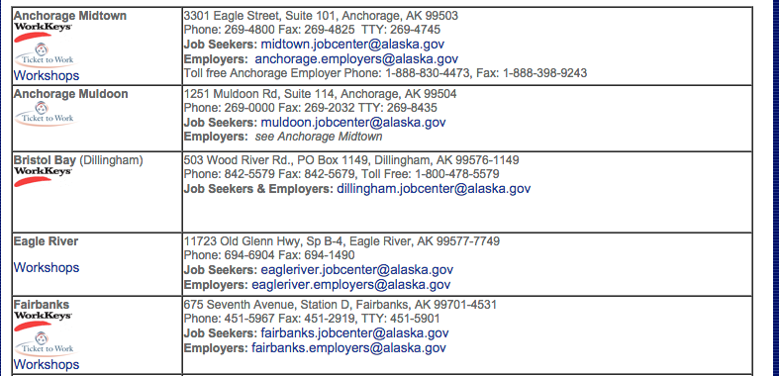

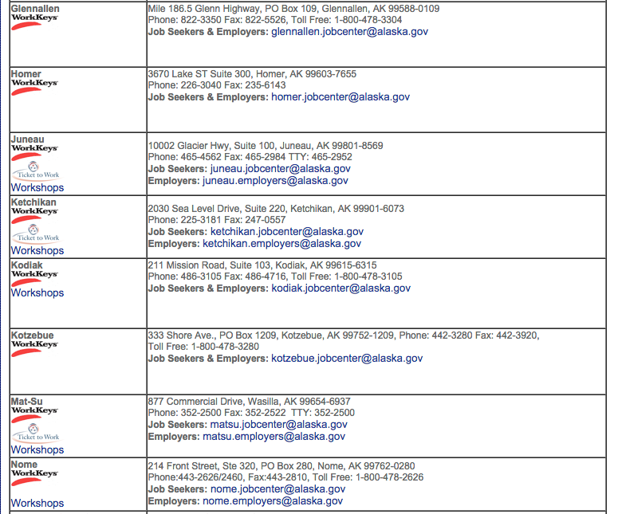

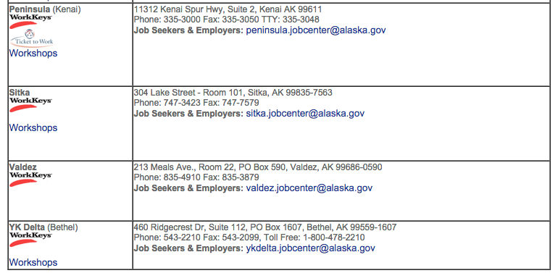
Division of Vocational Rehabilitation:
Regional Office Locations and Contact Numbers

